Autumn Show Jumping Series 2025  The Fife Riding Club Showground – Glenrothes  Sunday 05 October  Sunday 19 October  Sunday 09 November &  Sunday 23 November | 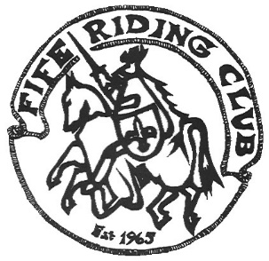

Entries via Equus platform. In the event of cancellation due to weather, entries will be refunded. Enter any two rounds, get third round FREE.

Class | Section | Restrictions
Class 1 | Cross Poles | Approx. height 45cm.  Cross poles, no fillers.
Class 2 | Beginners | Max 45cm. Mainly cross poles, some straight bars, some small spreads, no fillers.
Class 3 | Minimus | Height 50-55cm.  Fillers to side.
Class 4 | Nursery Novice | Height 60-65cm.
Class 5 | Novice | Height 70-75cm.
Class 6 | Intermediate | Height 80-85cm
Class 7 | Small Open | Height 90-95cm
Class 8 | Open | Height 100-105cm

Entry fee - £10 per class (Members/pre-paid)

STANDARD DISCLAIMER
Save for the death or personal injury caused by the negligence of the organisers or anyone for whom they are in law responsible, neither the organisers of any event to which these rules apply, nor any agent, employee or representative of these bodies accepts liability for any accident, loss, injury to horses, owners, riders, spectators, land or any other person or property whatsoever, whether caused by their negligence, breach of contract or in any other way whatsoever

